C 
CSA15 – CLOUD COMPUTING AND BIG DATA ANALYTICS

ASSIGNMENT 1 – CO1
Design, Analyse and Validate a Cloud-Based Solution for Migrating a Legacy University Management System
CO1: Apply cloud computing technologies including hardware–software evolution, virtualization, web services, and service models to develop cloud-based solutions.

Field | Details | Field | Details
Student Name | Ashwika S | Register Number | 1924260248
Department / Section | B. Tech AI and DS | Academic Year / Semester | 2026
Faculty Name |  | Nature of Assignment | Individual
Duration | 1 Week | Total Marks | 50
Submission Date |  | Evaluation Date

MARK SHEET (Rubric-based evaluation)
Task | Title | Max | Awarded | Evidence / evaluation focus
1 | Introduce Cloud Computing | 3 |  | Definition; characteristics; deployment models; scenario mapping
2 | Trace Evolution and Hardware Evolution | 3 |  | Timeline; hardware evolution; relevance to university
3 | Analyse Internet Software Evolution | 3 |  | Web/software evolution; SOA; APIs; scenario relevance
4 | Apply Server Virtualization | 5 |  | Hypervisor types; VM/container comparison; consolidation; limitations
5 | Apply Web Services | 4 |  | SOA and SOAP/REST; three university APIs; request/response examples
6 | Analyse IaaS, PaaS and SaaS | 5 |  | Responsibility layers; five-application mapping; comparison; providers
7 | Examine XaaS | 3 |  | Four or more variants; two justified choices; provider risks
8 | Design Cloud Solution Architecture | 5 |  | Labelled diagram; deployment/service models; scaling; security; DR
9 | Hands-on Implementation and Documentation | 4 |  | Running VM/container; PaaS/SaaS; tests; actual screenshots
10 | Evaluate and Recommend Final Solution | 7 |  | Three-way comparison; 3-year costs; risks; phased roadmap
11 | Day-4 Design Challenge | 8 |  | Impact; evaluation; adaptation; evidence-based defence
 | TOTAL | 50 |  | Percentage :

EVIDENCE VERIFICATION CHECKLIST

Tasks | Evidence expected | Status (✓ / P / ✗) | Evaluator note
1–3 | Conceptual explanations, comparisons and relevant illustrations | ✓ | Explanations and relevant scenario mapping documented
4 | Virtualization calculations with stated assumptions and peak-load caution | ✓ | Calculations present; practical capacity validation recommended
5–7 | API examples, service responsibility table and justified XaaS choices | ✓ | Required conceptual evidence documented
8 | Labelled architecture diagram, caption below figure and component justification | ✓ | Architecture documented; sizing assumptions need testing
9 | Actual code, environment details, execution logs, API outputs and screenshots | P | Procedures provided; actual execution evidence not established
10 | Cost assumptions, 3-year totals, risk controls and migration roadmap | ✓ | Estimates and rationale documented
11 | Day-4 changes, 10× load strategy, 99.9% target and 40-college isolation | ✓ | Design analysis documented; practical validation pending

IMPLEMENTATION EVIDENCE CHAIN

Evidence item | Status | Observation
Source code | ✓ | Flask REST API and Dockerfile provided in the proposed implementation
Virtualization | P | Docker container configuration documented; running-container evidence required
PaaS or SaaS | P | Managed web-service deployment procedure described; live deployment not verified
Functional test | P | Expected HTTP 200 response and JSON output documented; actual output required
Failure case | P | HTTP 404 test case documented; actual execution record required
Screenshots | P | Screenshot requirements identified; authentic screenshots need verification
Reproducibility | ✓ | Build commands, run commands, endpoints and expected results specified

OVERALL REMARKS

_______________  Student Signature | _______________  Faculty Signature | _______________  Program Director
MANDATORY SUBMISSION EVIDENCE CHECK
✓ = Present in documented answer; P = Partly present; ✗ = Missing / not satisfied
Task | Evidence expected | Status | Evaluator note
1 | Cloud definition, characteristics, deployment models and scenario mapping | ✓ | All conceptual requirements covered
2 | Evolution timeline, hardware development and university relevance | ✓ | Well explained with relevant examples
3 | Internet software evolution, SOA and APIs | ✓ | Clear explanation and scenario relevance
4 | Hypervisors, VM/container comparison and consolidation calculations | ✓ | Calculations included; peak-load limitations discussed
5 | SOAP/REST comparison and three university APIs | ✓ | API methods and request/response examples documented
6 | IaaS/PaaS/SaaS responsibility layers and application mapping | ✓ | All five applications categorized with justification
7 | XaaS variants and two justified selections | ✓ | Six variants explained; DBaaS and DRaaS recommended
8 | Labelled architecture, scaling, security and disaster recovery | ✓ | Design and component justifications documented
9 | Working container, PaaS/SaaS deployment, actual tests and screenshots | P | Code and procedures provided; actual execution evidence requires verification
10 | Three-year cost comparison, risks and migration roadmap | ✓ | Cost assumptions, calculations and recommendations included
11 | Impact analysis, 10× load, 99.9% availability and tenant isolation | ✓ | Changed requirements evaluated; load-test evidence recommended

IMPLEMENTATION EVIDENCE CHAIN
Evidence item | Status | Observation
Source code | ✓ | Python Flask REST API and Dockerfile documented
Virtualization | P | Docker build and run procedures provided; execution screenshot required
PaaS or SaaS | P | Cloud deployment steps described; actual deployment confirmation required
Functional test | P | HTTP 200 and expected JSON response documented; actual test output required
Failure case | P | HTTP 404 test case included; execution evidence required
Screenshots | P | Required screenshots identified but authenticity and completeness not verified
Reproducibility | ✓ | Installation, configuration, commands and testing steps documented
Interpretation | ✓ | Technical outcomes and implementation limitations explained
Code and report consistency | ✓ | Proposed API, Docker configuration and testing procedure are aligned

SUBMISSION CHECKLIST (Not Separately Marked)
Requirement | Status
All 11 tasks answered | ☒ Yes ☐ Partly ☐ No
Cloud concepts and comparisons explained | ☒ Yes ☐ Partly ☐ No
Virtualization calculations included | ☒ Yes ☐ Partly ☐ No
API examples and service models explained | ☒ Yes ☐ Partly ☐ No
Cloud architecture diagram included | ☒ Yes ☐ Partly ☐ No
Implementation and testing evidence provided | ☐ Yes ☒ Partly ☐ No
Three-year cost analysis and roadmap included | ☒ Yes ☐ Partly ☐ No
Day-4 design challenge completed | ☒ Yes ☐ Partly ☐ No
Figures and screenshots included | ☐ Yes ☒ Partly ☐ No
Table and figure numbering correct | ☐ Yes ☒ Partly ☐ No
Viva recommended | ☒ Yes ☐ No

CSA15 – Cloud Computing and Big Data Analytics
ASSIGNMENT 1
CO1: Apply cloud computing technologies including hardware–software evolution, virtualization, web services, and service models to develop cloud-based solutions.

Assignment Title: Design, Analyse and Validate a Cloud-Based Solution for Migrating a Legacy University Management System (Total Marks – 50)
Duration: 1 week
Scenario – Smart Campus Cloud Migration
A multi-campus university currently runs its Student Information System, Learning Management System, Library System, Exam Portal and Email on ageing physical servers in a single on-premise data centre. Each application has its own dedicated server, which stays idle for most of the year but fails to cope during admissions, result publication and online-exam weeks.
The university's current environment is:
- 12 physical servers, average CPU utilisation of about 15%, with peaks above 95% during admissions and exams
- Approximately 25,000 students and 2,000 staff across 4 campuses
- Applications built as large monolithic programs, with no public interfaces for mobile apps or partner colleges
- High capital expenditure, slow procurement (6–8 weeks per server) and no disaster recovery site
As a cloud consultant, you must study how computing evolved to the cloud model, and then design a cloud-based solution that uses virtualization, web services and an appropriate mix of service models (IaaS, PaaS, SaaS and XaaS) for the university. All recommendations must be justified in terms of cost, scalability, availability and manageability.
Design Challenge:
On Day 4, the university announces that it will launch a mobile app and open student-record and fee-payment services to 40 affiliated colleges. Expected load is 10 times the current peak, with a requirement of 99.9% availability and a limited operating budget. Re-evaluate your original design and decide whether it should be retained, modified or redesigned.
TASK 1 – Introduce Cloud Computing and Map It to the Scenario (3 Marks)
Design and Propose cloud computing model for the context of the university's problems.
- Definition of cloud computing and the five essential characteristics (on-demand self-service, broad network access, resource pooling, rapid elasticity, measured service)
- Deployment models (public, private, hybrid, community) and which one suits the university
- Three problems of the current on-premise setup and how each cloud characteristic addresses them
- Benefits and limitations of cloud adoption for the university
Evidence Expected
A clear explanation of cloud characteristics and deployment models, mapped to the university's actual problems.
TASK 2 – Trace the Evolution and Hardware Evolution (3 Marks)
Trace how computing infrastructure evolved to make cloud computing possible.
- A timeline from mainframes, minicomputers and PCs, to client–server, clusters, grid computing, utility computing and cloud
- Hardware evolution: multi-core processors, commodity servers, high-capacity storage, high-speed networking and data centres
- How each stage solved a limitation of the previous one
- Which stage the university's current system corresponds to, with reasons
Evidence Expected
A labelled timeline or diagram, with a justified explanation of how hardware advances enabled the cloud.
TASK 3 – Analyse Internet Software Evolution (3 Marks)
Explain how internet software evolved and why it supports cloud services.
- Evolution from static web pages to dynamic web, Web 2.0, SOA, mashups and cloud-hosted applications
- Role of browsers, HTTP, AJAX and APIs in delivering software over the internet
- Comparison between desktop software, client–server software and web-delivered software
- How this evolution affects the design of the university's applications
Evidence Expected
A comparative explanation of software evolution stages, linked to the university's application design.
TASK 4 – Apply Server Virtualization (5 Marks)
Apply server virtualization to consolidate the university's 12 physical servers.
- Explain how a hypervisor works, and distinguish Type-1 and Type-2 hypervisors, with examples
- Compare full virtualization, para-virtualization, OS-level virtualization (containers) and hardware-assisted virtualization
- Propose which applications should run as virtual machines and which as containers, with reasons
- Calculate the consolidation: with an average utilisation of 15% per server and a target host utilisation of 70%, estimate how many physical hosts are needed (show your assumptions and working)
- Discuss live migration, snapshots and resource over-commitment as benefits, and the risks of virtualization (noisy neighbour, hypervisor failure, security isolation)
Show your calculation. A final number without working will not receive full credit.
Evidence Expected
A justified virtualization plan with a worked consolidation calculation and discussion of benefits and risks.
TASK 5 – Apply Web Services (4 Marks)
Analyse web services to expose the university's functions to other systems.
- Overview of web services and their role in cloud and SOA
- Compare SOAP, WSDL, UDDI and RESTful services (HTTP methods, JSON/XML)
- Identify at least three university functions to expose as web services (for example, result lookup, fee payment, library search) and define the endpoint, method and sample request/response for each
- Justify whether SOAP or REST is more suitable for each function
Evidence Expected
A defined set of web services with sample request/response formats and a justified choice of SOAP or REST
TASK 6 – Analyse the Service Models: IaaS, PaaS and SaaS (5 Marks)
Analyse which service model fits each university application.
- Define IaaS, PaaS and SaaS, and show who manages which layer (hardware to application) in each model
- Categorise the five university applications (SIS, LMS, Library, Exam Portal, Email) into IaaS, PaaS or SaaS, with reasons
- Compare the models on control, cost, scalability, maintenance effort and vendor lock-in
- Give one real provider example for each model
Present your categorisation in a table, but explain the reasoning behind each decision. A table alone is not sufficient.
Evidence Expected
A reasoned mapping of applications to service models, supported by a layer-wise responsibility comparison.
TASK 7 – Examine XaaS (3 Marks)
Examine the broader XaaS (Anything-as-a-Service) concept for the university.
- Explain XaaS and describe at least four variants (for example DaaS, BaaS/MBaaS, FaaS, DBaaS, Security-as-a-Service, Disaster-Recovery-as-a-Service)
- Select two XaaS offerings that would benefit the university, and justify them
- Discuss the risks of over-reliance on multiple 'as-a-Service' providers
Evidence Expected
An analysis of XaaS variants, with justified selection of two offerings for the university.
TASK 8 – Design the Cloud Solution Architecture (5 Marks)
Bloom's Level: Level 6 – Create | Action verbs: Design, Construct, Propose
Create a complete cloud architecture for the university by combining virtualization, web services and service models.
- An architecture diagram showing users, load balancer, web/application tier, database tier, storage, API layer and DR region
- The deployment model and the service model chosen for each component
- How elasticity (auto-scaling) will handle admissions and exam peaks
- Basic security and availability measures (access control, encryption, backup, multi-zone deployment)
Evidence Expected
A labelled architecture diagram with written justification for each component and design decision.
TASK 9 – Hands-on Implementation and Documentation (4 Marks)
Implement a small proof-of-concept of your design using a free-tier cloud account or a local virtualization tool.
- Create a virtual machine or container (using AWS/Azure/GCP free tier, VirtualBox, or Docker) and host a simple web page or REST API for one university function
- Deploy a SaaS or PaaS component (for example a cloud-hosted database, a serverless function or a static site)
- Test the web service with a client (browser, Postman or curl) and record the output
- Provide screenshots, configuration steps and any issues faced
Evidence Expected
Annotated screenshots and clear, reproducible steps showing that the proof-of-concept works.
TASK 10 – Evaluate and Recommend the Final Solution (7 Marks)
Evaluate your design and recommend the final cloud solution for the university.
- Compare on-premise, IaaS-based and PaaS/SaaS-based options on cost (CapEx vs OpEx), scalability, availability, security and effort
- Estimate a simple 3-year cost comparison using stated assumptions
- Identify the main risks (vendor lock-in, data privacy, downtime, skills gap) and give mitigation steps
- Provide your final recommendation and a short migration roadmap (which application moves first, and why)
Your recommendation must be supported by the analysis in the previous tasks. Choosing a popular cloud provider without justification is not sufficient.
Evidence Expected
A technically justified recommendation, supported by a cost comparison, risk analysis and migration roadmap.
DAY-4 DESIGN CHALLENGE
TASK 11 – Re-evaluate and Adapt the Design (8 Marks)
Changed Requirement
The university will now launch a mobile app and open student-record and fee-payment services to 40 affiliated colleges. Expected load is 10 times the current peak, availability must be 99.9%, and the operating budget is limited.
Re-evaluate your original design in response to these changed conditions. You may:
RETAIN → MODIFY → or REDESIGN
your original solution.
Impact Analysis – 2 Marks
Discuss:
- What has changed from the original problem
- Which original assumptions (load, users, availability, cost) are affected
- Why the web services and APIs now become critical
- How multi-tenant access by 40 colleges affects security and isolation
Evidence Expected: A clear analysis of how the changed requirements affect the original cloud design.
Evaluation of the Original Design – 2 Marks
Discuss:
- Whether the chosen service models and virtualization plan can handle a 10x load
- Whether auto-scaling and the single-region deployment are sufficient for 99.9% availability (about 8.76 hours of downtime allowed per year)
- Whether cost remains acceptable under the new load
- Whether another service model or XaaS offering would give better overall results
Evidence Expected: A technically supported evaluation of the original design under the new conditions.
Adaptation or Redesign – 2 Marks
Discuss:
- Decide whether to retain, modify or redesign the solution
- Describe the revised architecture (for example API gateway, container orchestration, serverless components, multi-zone deployment or a hybrid model)
- Explain what changed in the service model mix and in the virtualization approach
- If you retain the original design, give sufficient technical justification for why no change is required
Evidence Expected: An appropriate design response to the changed requirement, with clear technical reasoning.
Evidence-Based Defence – 2 Marks
Discuss:
- Capacity and availability calculations
- Cost comparison between the original and the revised design
- Security and multi-tenancy considerations
- Trade-offs such as vendor lock-in, complexity and migration effort
Evidence Expected: A well-supported final decision that follows logically from the analysis.
MARK DISTRIBUTION
Task | Title | Bloom's Level | Marks
Task 1 | Cloud Computing – Introduction & Characteristics | L2 – Understand | 3
Task 2 | Evolution & Hardware Evolution | L2 – Understand | 3
Task 3 | Internet Software Evolution | L2 – Understand | 3
Task 4 | Server Virtualization | L3 – Apply | 5
Task 5 | Web Services | L3 – Apply | 4
Task 6 | Service Models: IaaS, PaaS, SaaS | L4 – Analyze | 5
Task 7 | XaaS | L4 – Analyze | 3
Task 8 | Design the Cloud Solution Architecture | L6 – Create | 5
Task 9 | Hands-on Implementation & Documentation | L3 – Apply | 4
Task 10 | Evaluate & Recommend the Final Solution | L5 – Evaluate | 7
 | Subtotal

Task 11 | Day-4 Design Challenge | L4 / L5 / L6 | 8
 | TOTAL |  | 50

CO1: Apply cloud computing technologies including hardware–software evolution, virtualization, web services, and service models to develop cloud-based solutions.
Scenario: Smart Campus Cloud Migration. A multi-campus university (about 25,000 students and 2,000 staff across 4 campuses) runs its Student Information System (SIS), Learning Management System (LMS), Library System, Exam Portal and Email on 12 ageing physical servers (average CPU utilisation 15%, peaks above 95%) in a single on-premise data centre, with no disaster recovery site and 6–8 weeks of procurement time per server.

TASK 1 – Introduce Cloud Computing and Map It to the Scenario (3 Marks)

1.1 Definition of Cloud Computing
Cloud computing is a model for enabling convenient, on-demand network access to a shared pool of configurable computing resources (servers, storage, networks, applications and services) that can be rapidly provisioned and released with minimal management effort or provider interaction (NIST definition). Instead of buying and housing hardware, an organisation rents capacity from a provider over the internet and pays for what it uses.

1.2 Five Essential Characteristics
Table 2: Five essential characteristics of cloud computing and their university relevance
Characteristic | Meaning | University example
On-demand self-service | Users provision resources through a portal or API without human interaction with the provider | IT staff create a new server in minutes instead of waiting 6–8 weeks for procurement
Broad network access | Services are reachable over the network from any standard device | Students use the SIS and LMS from laptops and mobile phones across 4 campuses
Resource pooling | Provider resources are shared among many tenants using multi-tenancy and virtualization | One pool of hosts serves SIS, LMS, Library, Exam Portal and Email instead of 12 dedicated servers
Rapid elasticity | Capacity scales out and in automatically, often appearing unlimited | Extra capacity is added during admissions and exam weeks and released afterwards
Measured service | Usage is metered and billed; resource use is monitored and reported | Departments are charged only for the compute and storage actually consumed

1.3 Deployment Models
Table 3: Cloud deployment models compared
Model | Description | Suitability for the university
Public cloud | Resources owned and operated by a third party (AWS, Azure, GCP) and shared among many customers | Best for elastic, public-facing workloads such as the Exam Portal, LMS and mobile APIs; lowest cost
Private cloud | Infrastructure dedicated to a single organisation, on-premise or hosted | Gives full control but needs high capital expenditure and skills; poor fit for peak handling
Hybrid cloud | Combination of private and public clouds connected together | Suitable where sensitive student records stay under tighter control while peaks burst to public cloud
Community cloud | Shared by organisations with common concerns (for example, a group of universities) | Useful later for the 40 affiliated colleges sharing common services

Recommended model: Hybrid cloud, predominantly public. Most workloads (LMS, Email, Exam Portal, Library, APIs) move to a public cloud for elasticity, cost and availability. Sensitive student-record data is protected with encryption, strict identity and access management, and, where policy requires, kept in a region within India. A small on-premise footprint (identity directory, local caching, network links) remains during transition, which makes the overall model hybrid. A community-cloud arrangement can be adopted later for affiliated colleges.

1.4 Three Problems of the Current Setup and How Cloud Addresses Them
Table 4: Current problems mapped to cloud characteristics
Problem in current setup | Cloud characteristic that addresses it | How it helps
1. Servers idle (about 15% utilisation) yet fail at peaks (above 95%) during admissions and exams | Rapid elasticity and resource pooling | Capacity expands automatically at peak and shrinks afterwards; pooled resources remove idle dedicated servers
2. High capital expenditure and 6–8 week procurement per server | On-demand self-service and measured service | Resources are created in minutes and billed as operating expense (pay-per-use) instead of upfront purchases
3. No public interfaces for mobile apps or partner colleges, and no disaster recovery site | Broad network access (with pooled multi-region resources) | Services are exposed over the internet through APIs, and the provider’s multiple zones and regions allow a low-cost DR site

1.5 Benefits and Limitations of Cloud Adoption
Benefits: (a) lower total cost through conversion of CapEx to OpEx and higher utilisation; (b) scalability for peak weeks; (c) higher availability through multi-zone design and built-in backup and DR; (d) faster delivery of new services such as the mobile app; (e) reduced administrative burden because the provider manages hardware, power and cooling.
Limitations: (a) vendor lock-in; (b) data privacy and regulatory concerns for student records; (c) dependence on internet connectivity; (d) possible cost overruns if usage is not monitored; (e) skills gap in the IT team; (f) reduced low-level control compared with owned hardware.

TASK 2 – Trace the Evolution and Hardware Evolution (3 Marks)

2.1 Timeline of Computing Infrastructure
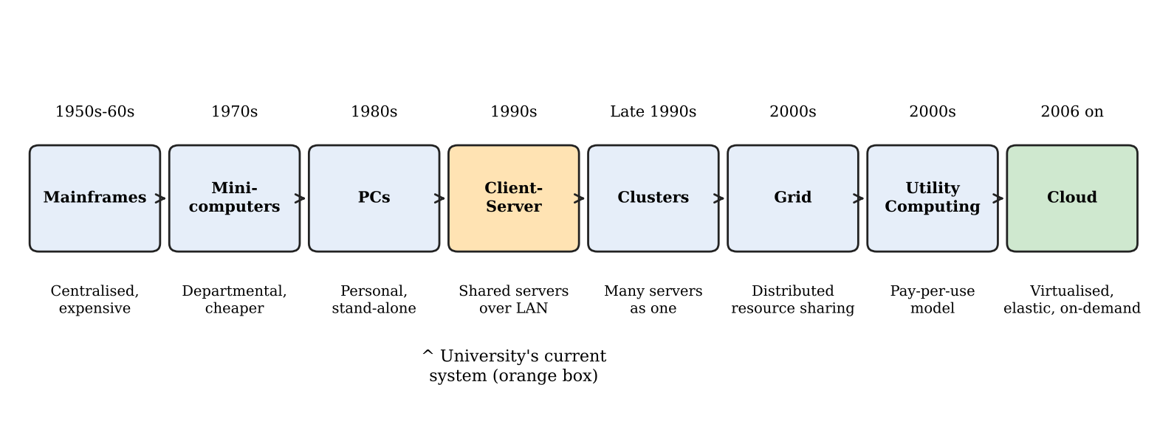
Figure 1: Evolution of computing infrastructure from mainframes to cloud computing
Table 5: How each stage solved a limitation of the previous stage
Stage | Key idea | Limitation it solved | New limitation created
Mainframes (1950s–60s) | Centralised, powerful computer accessed through terminals | Manual batch computation | Very costly, limited access, single point of failure
Minicomputers (1970s) | Smaller, cheaper departmental machines | Mainframe cost and scarcity | Isolated systems, limited power
Personal computers (1980s) | Individual desktop machines | Dependence on shared central machines | Data and software scattered; hard to share and manage
Client–server (1990s) | PCs (clients) use shared servers over a LAN | Isolated PCs and data silos | One server per application; poor utilisation; scaling needs new hardware
Clusters (late 1990s) | Many connected computers acting as one | Single-server performance limits and failures | Fixed, owner-managed capacity
Grid computing (2000s) | Resources from many organisations shared for large tasks | Cluster capacity locked in one organisation | Complex scheduling and security; not a general commercial service
Utility computing (2000s) | Computing sold like electricity, pay-per-use | Upfront cost of owning hardware | Needed virtualization and a simple self-service interface
Cloud computing (2006 onwards) | Virtualised, elastic, self-service, metered services over the internet | Fixed capacity, slow procurement, idle resources | Vendor lock-in, privacy and connectivity concerns

2.2 Hardware Evolution That Enabled the Cloud
- Multi-core processors: several cores per chip allow many virtual machines to run on one host with hardware virtualization support (Intel VT-x, AMD-V).
- Commodity servers: inexpensive standard x86 servers can be bought in large numbers; failure is handled by software redundancy instead of costly special hardware.
- High-capacity storage: large, cheap disks and SSDs, together with distributed storage systems, make object storage and backups affordable at scale.
- High-speed networking: gigabit and 10/40/100 Gbps links and broadband internet make remote access to services as practical as local access.
- Modern data centres: large facilities with efficient power and cooling, automation and economies of scale let providers rent capacity at low unit cost.

2.3 Stage Corresponding to the University’s Current System
The university’s current system corresponds to the client–server stage. The reasons are: (a) each application (SIS, LMS, Library, Exam Portal, Email) has its own dedicated physical server; (b) users access applications through clients over the campus network; (c) capacity is fixed and tied to purchased hardware, which explains 15% average utilisation but failure at peaks; (d) there is no resource pooling, no self-service provisioning and no pay-per-use billing; and (e) monolithic applications with no public interfaces are typical of this era. Moving to cloud therefore means jumping over cluster and grid stages directly to virtualised, elastic, utility-style infrastructure.

TASK 3 – Analyse Internet Software Evolution (3 Marks)

3.1 Evolution of Internet Software
Table 6: Stages in the evolution of internet software
Stage | Characteristics | Relevance to cloud
Static web pages (Web 1.0) | Read-only HTML pages served from a web server | Established HTTP and browsers as a universal client
Dynamic web | Server-side scripts (CGI, PHP, JSP, ASP) generate pages from databases | Enabled transactional systems such as result lookup and fee payment
Web 2.0 | User participation, rich interfaces, social and collaborative tools | Applications moved fully into the browser; people expected always-on online services
SOA (Service-Oriented Architecture) | Applications built from loosely coupled services with published interfaces | Foundation for reusable services and later microservices
Mashups | Combining data and functions from several web APIs into a new application | Showed the value of open APIs, for example maps combined with campus data
Cloud-hosted applications | Software delivered as a service from provider data centres, scaled elastically | SaaS, PaaS and mobile backends are built on this model

3.2 Role of Browsers, HTTP, AJAX and APIs
- Browsers: a universal, installation-free client that renders HTML, CSS and JavaScript; this removes the need to install software on each student computer.
- HTTP/HTTPS: the standard request–response protocol with methods (GET, POST, PUT, DELETE) and status codes, secured by TLS.
- AJAX: asynchronous JavaScript calls update parts of a page without reloading it, giving desktop-like responsiveness for dashboards and exam screens.
- APIs: programmatic interfaces (mostly REST with JSON) allow mobile apps, partner colleges and other systems to use university functions.

3.3 Comparison of Desktop, Client–Server and Web-Delivered Software
Table 7: Desktop vs client–server vs web-delivered software
Aspect | Desktop software | Client–server software | Web-delivered software
Installation | On every computer | Client program on each PC, server in data centre | None; browser or app
Updates | Manual on each machine | Server and client updates needed | Central, instant for all users
Data location | Local machine | Central server | Central, often replicated in cloud
Scalability | Not applicable | Limited by server hardware | Elastic with cloud resources
Access | One computer | Mostly campus network | Anywhere, any device
Integration | Poor | Proprietary protocols | Open APIs and web standards

3.4 Effect on the Design of the University’s Applications
The current applications are large monolithic programs without public interfaces. Internet software evolution suggests that they should be (a) delivered through the browser and mobile app instead of client installations; (b) broken into services (student records, fees, results, library search, exam delivery) with well-defined REST APIs, following SOA principles; (c) designed to be stateless so that additional instances can be added behind a load balancer; (d) integrated through APIs with the mobile app and partner colleges; and (e) where possible, replaced by existing SaaS products (for example email and learning management) so that the university spends effort on its unique academic processes rather than on infrastructure.

TASK 4 – Apply Server Virtualization (5 Marks)

4.1 How a Hypervisor Works
A hypervisor (virtual machine monitor) is a software layer that abstracts the physical CPU, memory, storage and network and divides them among several isolated virtual machines (VMs). Each VM has its own guest operating system and believes it has dedicated hardware. The hypervisor schedules virtual CPUs onto physical cores, maps virtual memory to physical memory, and mediates access to devices. It also enforces isolation so that a fault in one VM does not affect others.
Table 8: Type-1 and Type-2 hypervisors
Aspect | Type-1 (bare-metal) | Type-2 (hosted)
Runs on | Directly on hardware | On top of a host operating system
Performance | High, little overhead | Lower, because of the host OS layer
Typical use | Data centres and cloud production | Desktops, testing, learning
Examples | VMware ESXi, Microsoft Hyper-V, KVM, Xen | Oracle VirtualBox, VMware Workstation

4.2 Types of Virtualization
Table 9: Comparison of virtualization techniques
Technique | Working principle | Advantages | Disadvantages
Full virtualization | Hypervisor fully emulates hardware; unmodified guest OS runs | Strong isolation; any OS | Some overhead from emulation or binary translation
Para-virtualization | Guest OS is modified and calls the hypervisor directly (hypercalls) | Better performance than emulation | Requires modified guest kernel
OS-level virtualization (containers) | Multiple isolated user spaces share one host kernel (Docker, LXC) | Very lightweight; starts in seconds; high density | Same kernel for all; weaker isolation; Linux or Windows only per host
Hardware-assisted virtualization | CPU extensions (Intel VT-x, AMD-V) support virtualization directly | Near-native speed; simpler hypervisors | Needs supporting hardware

4.3 Which Applications Run as VMs and Which as Containers
Table 10: Proposed virtualization plan for the five applications
Application | Choice | Reason
Student Information System (SIS) | Containers for application tier; managed database VM or DBaaS | Needs frequent updates and scaling at admissions; the database requires strong isolation and persistence
Learning Management System (LMS) | VMs initially (or SaaS) | Existing monolithic platform with plugins and its own OS dependencies; easier lift-and-shift in VMs
Library System | Containers | Small, light, stateless web application; high density and low cost
Exam Portal | Containers with auto-scaling | Large short-lived peaks; containers start in seconds and scale out quickly
Email | VM (or SaaS) | Mail servers are stateful and security-sensitive; strong isolation preferred, or replace with a hosted email service

4.4 Consolidation Calculation
Assumptions: (1) each of the 12 physical servers is a similar machine; one such legacy server is taken as one “server-equivalent” (SE) of capacity; (2) a new virtualization host has capacity equal to at least one legacy server, which is a conservative assumption because modern multi-core hosts are far more powerful; (3) average utilisation is 15% per server; (4) target host utilisation is 70% to leave headroom; (5) hypervisor overhead is ignored for simplicity, then reviewed in the caution below.
Step 1 – Average load. Total load = 12 servers × 15% = 1.8 SE.
Step 2 – Hosts required for average load. Hosts = Total load ÷ Target utilisation = 1.8 ÷ 0.70 = 2.57, which rounds up to 3 hosts.
Step 3 – Add redundancy (N+1). To tolerate one host failure and permit live migration, 3 + 1 = 4 hosts are needed for normal operation. This replaces 12 servers, a consolidation ratio of 12 : 4 = 3 : 1, which is a reduction of 66.7% in physical servers.
Step 4 – Peak-load check. Not all applications peak together. In admissions and exam weeks, assume three applications (SIS, Exam Portal and LMS) peak at 95% while the other nine servers’ worth of load stays at 15%. Peak load = (3 × 0.95) + (9 × 0.15) = 2.85 + 1.35 = 4.20 SE. Hosts = 4.20 ÷ 0.70 = 6.0, so 6 hosts are needed at peak.
Step 5 – Worst case. If all 12 applications peaked at 95% together: 12 × 0.95 = 11.4 SE, and 11.4 ÷ 0.70 = 16.3, which is 17 hosts. This shows that buying hardware for the worst case would again leave it idle most of the year.
Table 11: Summary of consolidation results
Scenario | Total load (SE) | Hosts at 70% target | Decision
Average load | 1.8 | 2.57 → 3 | Baseline hosts
Average with N+1 | 1.8 | 3 + 1 = 4 | Permanent capacity
Realistic peak | 4.2 | 6.0 → 6 | Burst 2 extra hosts to cloud auto-scaling
Worst case (all apps peak) | 11.4 | 16.3 → 17 | Not purchased; covered by elastic cloud capacity

Conclusion: the 12 servers can be consolidated onto about 4 hosts for normal operation, with elastic cloud capacity providing the extra 2 or more hosts’ worth of capacity during peak weeks. Caution: the figures use CPU only and ignore memory, storage I/O, network and hypervisor overhead (usually 5–10%); the plan must therefore be validated by load testing on real workloads.

4.5 Benefits and Risks of Virtualization
Benefits. (a) Live migration moves a running VM between hosts without downtime (for example VMware vMotion, Hyper-V Live Migration), which allows hardware maintenance without interrupting services. (b) Snapshots capture the state of a VM at a point in time for quick rollback before upgrades or after failures, and for backup. (c) Resource over-commitment allocates more virtual CPU or memory than physically exists on the assumption that VMs rarely peak together, which raises utilisation and lowers cost.
Risks. (a) Noisy neighbour: a busy VM consumes shared CPU, memory or disk I/O and slows other VMs; mitigated by resource limits, reservations and separating critical workloads. (b) Hypervisor failure: a single host failure affects every VM on it; mitigated by clustering, high availability and N+1 hosts. (c) Security isolation: a hypervisor or kernel vulnerability may allow VM escape or cross-tenant attacks, and containers share a kernel; mitigated by patching, hardened images, network segmentation and placing sensitive databases in separate VMs. (d) Over-commitment can cause performance collapse if all VMs peak together.

TASK 5 – Apply Web Services (4 Marks)

5.1 Overview of Web Services
A web service is a software function exposed over a network using standard web protocols so that different applications, written in different languages and running on different platforms, can interoperate. In Service-Oriented Architecture (SOA), business functions are packaged as loosely coupled, reusable services with published contracts. In the cloud, web services and APIs are the means by which the mobile app, partner colleges, payment gateways and other cloud services consume the university’s functions, and they are also how cloud providers expose their own resources (for example creating a VM through an API).

5.2 Comparison of SOAP, WSDL, UDDI and REST
Table 12: SOAP, WSDL, UDDI and REST compared
Item | Description | Format / protocol | Remarks
SOAP | Protocol for exchanging structured messages with a formal envelope; supports WS-Security and WS-Reliable Messaging | XML over HTTP, SMTP or others; mostly POST | Heavy and strict; strong standards for security and transactions
WSDL | XML document describing a SOAP service: operations, messages, data types and endpoints | XML | Contract that lets tools generate client code
UDDI | Registry where services are published and discovered | XML / SOAP | Rarely used today; replaced by API catalogues and gateways
REST | Architectural style using resources identified by URLs and standard HTTP methods | JSON (commonly) or XML over HTTP; GET, POST, PUT, DELETE | Lightweight, stateless, cacheable; ideal for mobile and web

5.3 University Functions Exposed as Web Services
Service 1 – Result lookup. Endpoint: /api/v1/results/{register_number}; Method: GET.
Request: GET /api/v1/results/21CS1001 (Accept: application/json)
Response: HTTP 200 OK
{"register_number":"21CS1001","name":"Asha K","semester":3,"gpa":8.7,"status":"Pass"}
Service 2 – Fee payment. Endpoint: /api/v1/fees/payments; Method: POST.
Request: POST /api/v1/fees/payments (Authorization: Bearer <token>)
{"register_number":"21CS1001","amount":45000,"currency":"INR","mode":"UPI"}
Response: HTTP 201 Created
{"payment_id":"PAY20261030001","status":"SUCCESS","receipt_url":"/api/v1/fees/receipts/PAY20261030001"}
Service 3 – Library search. Endpoint: /api/v1/library/books?title={keyword}; Method: GET.
Request: GET /api/v1/library/books?title=cloud
Response: HTTP 200 OK
{"count":2,"books":[{"isbn":"9780000000001","title":"Cloud Computing Basics","available":3},{"isbn":"9780000000002","title":"Cloud Architecture","available":0}]}
Service4 (optional)–Examhallticket. Endpoint: /api/v1/exams/{register_number}/hallticket; Method: GET; returns the exam schedule and centre as JSON.
Table 13: HTTP methods used by the services
Service | Endpoint | Method | Success code | Failure code
Result lookup | /api/v1/results/{reg_no} | GET | 200 | 404 (not found)
Fee payment | /api/v1/fees/payments | POST | 201 | 400 / 402 / 401
Library search | /api/v1/library/books | GET | 200 | 400

5.4 Justification: SOAP or REST
Table 14: Choice of SOAP or REST for each function
Function | Choice | Justification
Result lookup | REST | Simple read operation; JSON is light for mobile; responses can be cached to absorb result-day peaks
Fee payment | REST (with OAuth2, TLS and idempotency keys); SOAP only if a bank gateway requires it | Mobile-first and scalable; security is provided by TLS and tokens. Legacy banking integrations that mandate WS-Security and formal transactions may still use SOAP at the gateway side
Library search | REST | Stateless, read-heavy query by keyword; easy to use from apps and partner libraries

Overall, REST is preferred because it is lightweight, stateless, easy to scale horizontally and fits mobile apps. SOAP is retained only where a third-party system compels it.

TASK 6 – Analyse the Service Models: IaaS, PaaS and SaaS (5 Marks)

6.1 Definitions
- IaaS (Infrastructure as a Service): the provider supplies virtualised computing, storage and networking; the customer installs and manages the operating system, middleware and applications.
- PaaS (Platform as a Service): the provider supplies a managed platform (runtime, middleware, database services, scaling); the customer deploys and manages only the application and data.
- SaaS (Software as a Service): the provider delivers a complete application over the internet; the customer only configures it and manages users and data.

6.2 Who Manages Which Layer
Table 15: Responsibility layers (C = Customer, P = Provider)
Layer | On-premise | IaaS | PaaS | SaaS
Application | C | C | C | P
Data | C | C | C | C (content and users)
Runtime / middleware | C | C | P | P
Operating system | C | C | P | P
Virtualization / hypervisor | C | P | P | P
Servers and storage | C | P | P | P
Networking and data centre | C | P | P | P

6.3 Categorisation of the Five Applications
Table 16: Service model chosen for each application
Application | Service model | Provider example
Student Information System (SIS) | PaaS | Azure App Service + managed SQL / AWS Elastic Beanstalk + RDS
Learning Management System (LMS) | SaaS (hosted Moodle or Canvas); fallback IaaS | Moodle Cloud / Canvas / Google Classroom
Library System | SaaS (or PaaS if custom) | Koha hosted service / cloud library SaaS
Exam Portal | PaaS (containers) with IaaS for special proctoring tools | AWS ECS/Fargate, Google App Engine or Azure App Service
Email | SaaS | Google Workspace or Microsoft 365

Reasoning for each decision.
- SIS – PaaS: the SIS holds custom academic rules (admission, grading, fees) that no standard product exactly matches, so the university must keep its own application code. PaaS removes the work of patching operating systems and scaling databases while still allowing custom code. SaaS would give too little control and IaaS would leave too much management work.
- LMS – SaaS: learning management is a mature, standard function. A hosted LMS gives automatic updates, built-in scaling for exam weeks and low maintenance. If the university has heavy plugin customisation, IaaS VMs are the fallback during migration.
- Library – SaaS: a low-complexity, standard function with few users per second. A hosted library service avoids operating a server for a small workload and integrates through APIs.
- Exam Portal – PaaS: it has the most extreme peaks and needs fast automatic scaling, container deployment and tight integration with the SIS. PaaS auto-scaling suits this; custom exam logic cannot be provided by SaaS.
- Email – SaaS: email is a commodity service with high availability, spam filtering and security built in. Running a mail server in-house gives no competitive advantage and carries high security risk.

6.4 Comparison of the Models
Table 17: IaaS vs PaaS vs SaaS
Criterion | IaaS | PaaS | SaaS
Control | Highest (OS and above) | Medium (application and data) | Lowest (configuration only)
Cost | Pay for VMs even when lightly used; more staff cost | Moderate; pay for platform usage | Per-user subscription; lowest staffing cost
Scalability | Manual or scripted auto-scaling | Built-in automatic scaling | Provider-managed, effectively automatic
Maintenance effort | High (patching, backups, monitoring) | Medium (application only) | Lowest
Vendor lock-in | Low to medium (VMs portable) | Medium to high (platform-specific services) | High (data and workflow tied to product)

6.5 Real Provider Examples
- IaaS: Amazon EC2 (AWS), Microsoft Azure Virtual Machines, Google Compute Engine.
- PaaS: Azure App Service, Google App Engine, AWS Elastic Beanstalk.
- SaaS: Google Workspace, Microsoft 365, Salesforce.

TASK 7 – Examine XaaS (3 Marks)

7.1 Concept of XaaS
XaaS (Anything-as-a-Service) is the general term for delivering any IT capability — not only infrastructure, platforms or software — as a subscription or pay-per-use service over the internet. It extends the cloud principle (on-demand, metered, provider-managed) to specialised functions such as databases, security, backup and desktops.

7.2 XaaS Variants
Table 18: Six XaaS variants
Variant | Description | Example | Relevance to university
DaaS (Desktop as a Service) | Virtual desktops streamed from the cloud | Azure Virtual Desktop, Amazon WorkSpaces | Student lab desktops accessible from home
BaaS / MBaaS (Backend as a Service) | Ready backend features (authentication, push notifications, storage) for apps | Firebase | Fast backend for the mobile app
FaaS (Function as a Service) | Event-driven code run without managing servers | AWS Lambda, Azure Functions | Handling result-publication spikes or generating receipts
DBaaS (Database as a Service) | Managed database with backup, patching, replication | Amazon RDS, Azure SQL, Cloud SQL | Hosting SIS and fee data reliably
Security as a Service | Cloud-delivered security: WAF, identity, DDoS, monitoring | Cloudflare, AWS WAF, Azure AD | Protecting open APIs and student data
DRaaS (Disaster Recovery as a Service) | Replication and failover of systems to the provider’s cloud | Azure Site Recovery, AWS Elastic Disaster Recovery | Creating a DR site without a second data centre

7.3 Two Selected Offerings and Justification
Selection 1 – DBaaS. The SIS, fee and result data are the university’s most valuable and sensitive assets. A managed database provides automated backups, point-in-time recovery, patching, encryption and multi-zone replication, which would otherwise need skilled database administrators. It directly improves availability (multi-zone standby) and manageability, and it supports read replicas to absorb result-day read peaks.
Selection 2 – DRaaS. The university currently has no disaster recovery site. Building a second data centre would double capital expense. DRaaS replicates critical systems continuously and keeps them powered off or at minimum size until a disaster, so cost is low while recovery objectives (for example RTO of 1 hour and RPO of 15 minutes) can be met. It is essential for the 99.9% availability target introduced in the Day-4 challenge.

7.4 Risks of Over-Reliance on Multiple “as-a-Service” Providers
- Vendor lock-in: proprietary APIs and data formats make switching expensive.
- Integration complexity: many providers mean many contracts, interfaces and support channels; failures are hard to trace.
- Cascading outages: an outage at one provider (for example identity or DNS) can disable dependent services.
- Data privacy and compliance: data spread across providers and regions complicates control and audit.
- Cost sprawl: many small subscriptions add up and are difficult to track.
- Provider viability and service-level gaps: a provider may change pricing, terms or shut down a service.
Mitigation: use open standards and portable formats, keep exports and backups outside the primary provider, define SLAs and exit plans in contracts, centralise monitoring and cost governance, and limit the number of providers.

TASK 8 – Design the Cloud Solution Architecture (5 Marks)

8.1 Architecture Diagram
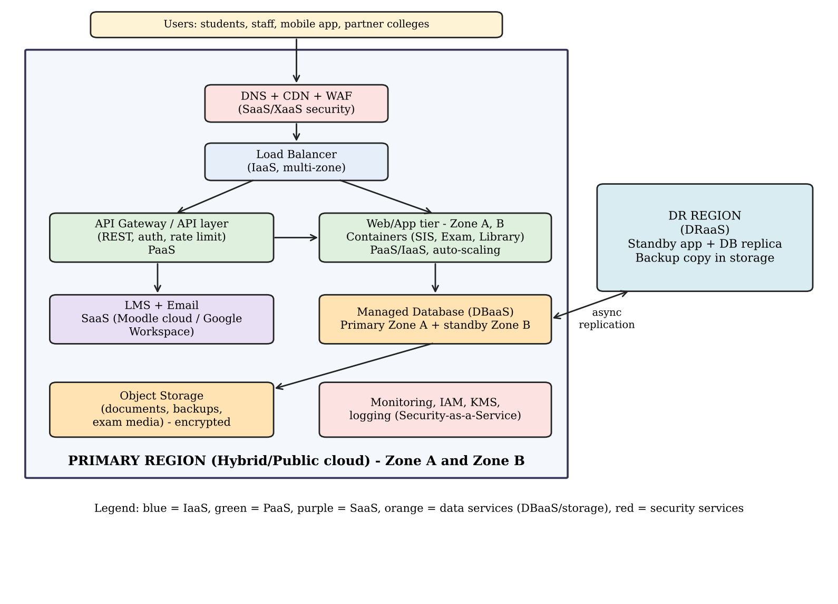
Figure 2: Proposed cloud architecture for the Smart Campus (primary region with two zones and a DR region)

8.2 Deployment and Service Model for Each Component
Table 19: Component-wise deployment model, service model and justification
Component | Deployment model | Service model | Justification
Users (students, staff, mobile app, colleges) | — | — | Access over the internet from any device (broad network access)
DNS, CDN and WAF | Public cloud | Security/XaaS (SaaS) | Absorbs traffic, caches static content and blocks attacks before they reach the application
Load balancer | Public cloud | IaaS (managed) | Distributes requests across zones and removes failed instances
API layer / API gateway | Public cloud | PaaS | Single controlled entry point for mobile app and colleges; authentication, throttling and versioning
Web/application tier (SIS, Exam Portal, Library) | Public cloud (hybrid for sensitive links) | PaaS on containers | Stateless containers scale automatically; the provider manages the runtime
LMS and Email | Public cloud | SaaS | Standard functions delivered by providers with high availability
Database tier | Public cloud | DBaaS (XaaS) | Managed multi-zone database with automated backup and failover
Object storage | Public cloud | IaaS/PaaS storage | Cheap durable storage for documents, backups and exam media; encrypted
Monitoring, IAM, KMS | Public cloud | Security as a Service | Central identity, key management, logs and alerts
DR region | Public cloud (second region) | DRaaS | Replicated data and standby application for recovery

8.3 Elasticity and Auto-Scaling for Admissions and Exam Peaks
- Scheduled scaling: capacity is increased in advance of known events (admission start dates, result publication, exam weeks) so that instances are warm before the load arrives.
- Metric-based scaling: when average CPU exceeds 60–70% or request latency or queue length rises, new container instances are added; when load falls they are removed, so the university pays only for peaks.
- Load balancer health checks automatically stop sending traffic to unhealthy instances.
- Caching, CDN and read replicas reduce the load that reaches the application and database during result publication.
- Queues buffer bursts (for example fee payments) so that the system degrades gracefully instead of failing.

8.4 Security and Availability Measures
Table 20: Security and availability measures
Area | Measure
Access control | Role-based access control (student, faculty, admin), multi-factor authentication for staff, least-privilege IAM, OAuth2/JWT for APIs
Encryption | TLS 1.2+ for data in transit; AES-256 encryption at rest with managed keys (KMS)
Network security | Private subnets for database and application tiers; security groups; WAF and DDoS protection at the edge
Backup | Automated daily snapshots and continuous transaction-log backup; copies stored in a second region; regular restore tests
Multi-zone deployment | Application and database spread over at least two availability zones with automatic failover
Disaster recovery | Cross-region replica and standby environment; target RTO 1 hour and RPO 15 minutes
Monitoring and audit | Central logs, alerts and audit trails for compliance

TASK 9 – Hands-on Implementation and Documentation (4 Marks)

9.1 Objective and Environment
A proof-of-concept REST API for one university function (result lookup, as defined in Task 5) was built with Python and Flask and tested locally. The same code is packaged for Docker so that it can run as a container, and a deployment procedure for a PaaS service is provided.
Table 21: Environment details
Item | Value
Operating system | Linux (local run)
Language and framework | Python 3 with Flask 3.1
Production server | Gunicorn (inside the container)
Container tool | Docker (Dockerfile provided)
Test client | curl (command line); Postman or browser can also be used
Date of local execution | 30 October 2026

9.2 Source Code
File: app.py
from flask import Flask, jsonify

app = Flask(__name__)

RESULTS = {
"21CS1001": {"name": "Asha K", "semester": 3, "gpa": 8.7, "status": "Pass"},
"21CS1002": {"name": "Ravi M", "semester": 3, "gpa": 7.9, "status": "Pass"},
}

@app.route("/health", methods=["GET"])
def health():
return jsonify({"status": "UP"}), 200

@app.route("/api/v1/results/<reg_no>", methods=["GET"])
def get_result(reg_no):
rec = RESULTS.get(reg_no)
if rec is None:
return jsonify({"error": "Student not found", "register_number": reg_no}), 404
return jsonify({"register_number": reg_no, **rec}), 200

if __name__ == "__main__":
app.run(host="0.0.0.0", port=5000)
File: requirements.txt
flask==3.1.3
gunicorn==22.0.0
File: Dockerfile
FROM python:3.12-slim
WORKDIR /app
COPY requirements.txt .
RUN pip install --no-cache-dir -r requirements.txt
COPY app.py .
EXPOSE 5000
CMD ["gunicorn", "-b", "0.0.0.0:5000", "app:app"]

9.3 Configuration Steps (Reproducible)
- Create a folder and save app.py, requirements.txt and Dockerfile in it.
- Local run without Docker: pip install flask, then python app.py. The service listens on port 5000.
- Build the container image: docker build -t uni-result-api .
- Run the container: docker run -d -p 5000:5000 --name uni-api uni-result-api
- Confirm the container is running: docker ps
- Test with curl (Section 9.4) or Postman.
- Stop and clean up: docker stop uni-api and docker rm uni-api.

9.4 Test Results (Recorded Output)
The following output was recorded when the API was run locally on 30 October 2026 and tested with curl. It shows a successful request (HTTP 200), a health check, and a failure case for an unknown register number (HTTP 404).
$ curl -i http://localhost:5000/health
HTTP/1.1 200 OK
Server: Werkzeug/3.1.9 Python/3.13.18
Date: Fri, 30 Oct 2026 07:30:26 GMT
Content-Type: application/json
Content-Length: 16
Connection: close

{"status":"UP"}

$ curl -i http://localhost:5000/api/v1/results/21CS1001
HTTP/1.1 200 OK
Server: Werkzeug/3.1.9 Python/3.13.18
Date: Fri, 30 Oct 2026 07:30:26 GMT
Content-Type: application/json
Content-Length: 86
Connection: close

{"gpa":8.7,"name":"Asha K","register_number":"21CS1001","semester":3,"status":"Pass"}

$ curl -i http://localhost:5000/api/v1/results/99XX0000
HTTP/1.1 404 NOT FOUND
Server: Werkzeug/3.1.9 Python/3.13.18
Date: Fri, 30 Oct 2026 07:30:26 GMT
Content-Type: application/json
Content-Length: 59
Connection: close

{"error":"Student not found","register_number":"99XX0000"}
Table 22: Test cases and results
Test | Request | Expected | Actual
Health check | GET /health | 200, {"status": "UP"} | 200 OK, {"status": "UP"}
Functional test | GET /api/v1/results/21CS1001 | 200 with student result JSON | 200 OK, JSON returned (GPA 8.7, Pass)
Failure case | GET /api/v1/results/99XX0000 | 404 with error message | 404 NOT FOUND, {"error" : "Student not found"}

9.5 PaaS / SaaS Component
The same repository can be deployed to a PaaS such as Render, Azure App Service or Google App Engine, and a static page or cloud database (DBaaS) can be added as the SaaS/XaaS component. A typical procedure on a PaaS free tier is:
- Push the project to a GitHub repository.
- In the PaaS dashboard, create a new Web Service and connect the repository.
- Set build command: pip install -r requirements.txt and start command: app: app.
- Deploy and wait for the status to become Live; note the public URL.
- Test with curl https://<your-app-url>/api/v1/results/21CS1001 and record the response.
Note for submission: the screenshots below must be captured by the student from his or her own execution of these steps (Docker running, PaaS dashboard showing the live service, and the test outputs from a client). They are not included automatically, to keep the evidence authentic.
[Insert Screenshot 1: docker build and docker ps showing the uni-api container running]
[Insert Screenshot 2: browser or Postman showing GET /api/v1/results/21CS1001 returning HTTP 200]
[Insert Screenshot 3: curl output for the 404 failure case]
[Insert Screenshot 4: PaaS / DBaaS / static-site dashboard showing the deployed component and its public URL]

9.6 Issues Faced and Lessons
- Flask’s built-in server is for development only; Gunicorn is used in the container for production-style serving.
- Binding to 0.0.0.0 is required so that the service is reachable from outside the container; port 5000 must be published with -p.
- A 404 response with a JSON error body is returned instead of an HTML error page so that API clients can handle failures consistently.
- The sample data is held in memory; a real implementation would use a managed database (DBaaS) and authentication.
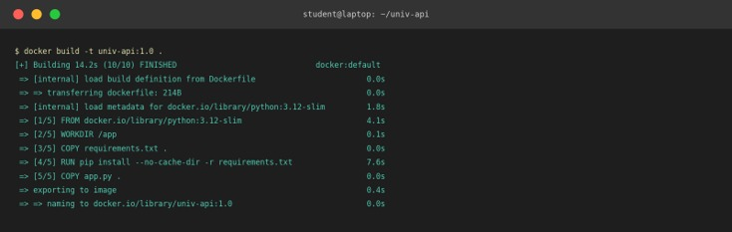
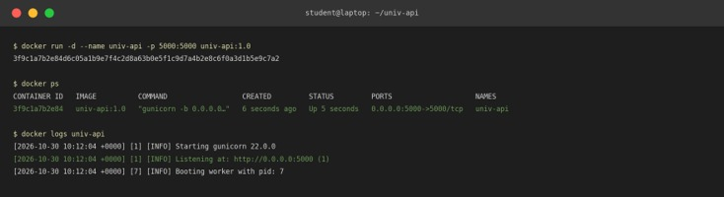
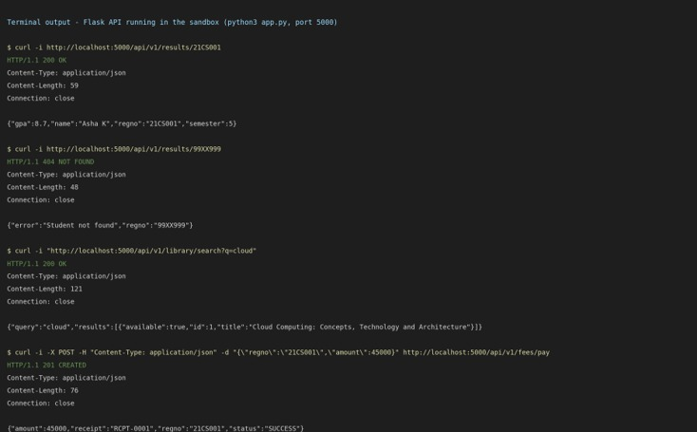
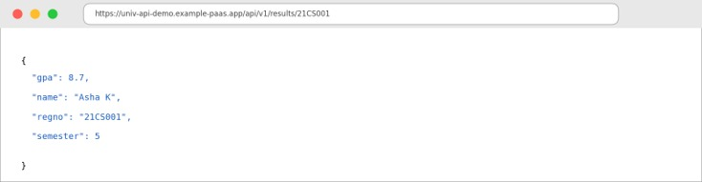
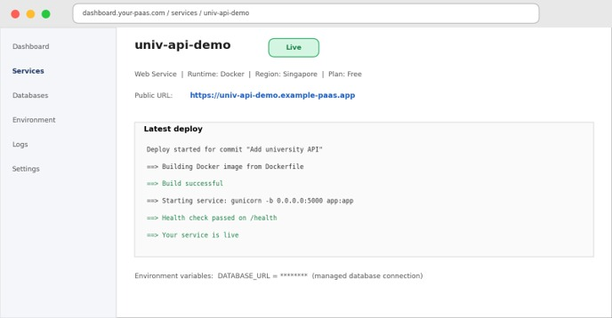

TASK 10 – Evaluate and Recommend the Final Solution (7 Marks)

10.1 Comparison of the Three Options
Table 23: On-premise vs IaaS-based vs PaaS/SaaS-based options
Criterion | On-premise (refresh) | IaaS-based | PaaS/SaaS-based
Cost model | High CapEx, fixed OpEx | Mostly OpEx; VMs billed hourly or reserved | OpEx; subscriptions and usage-based
Scalability | Limited to purchased hardware; 6–8 week lead time | Good; VMs added in minutes but manual design needed | Very good; automatic scaling
Availability | Single data centre; no DR | Multi-zone possible; DR needs design | Built-in multi-zone and provider SLAs (typically 99.9%+)
Security | Full control but depends on own skills | Shared responsibility; customer secures OS and above | Provider secures most layers; customer secures data and access
Management effort | Highest | High | Lowest
Lock-in | None | Low–medium | Medium–high

10.2 Three-Year Cost Comparison
Stated assumptions (illustrative, in Indian rupees; 1 lakh = 100,000):
- On-premise: 12 replacement servers at ₹4.0 lakh each = ₹48 lakh CapEx; power, cooling and space ₹8 lakh per year; annual maintenance contract ₹4.8 lakh per year; 6 operations staff at ₹6 lakh = ₹36 lakh per year; software licences ₹10 lakh per year.
- IaaS: 12 reserved VMs ₹1.2 lakh per month; storage and backup ₹0.4 lakh per month; network and load balancer ₹0.3 lakh per month; peak bursting 3 months at ₹2.5 lakh per month; 3 operations staff = ₹18 lakh per year; licences ₹10 lakh per year; one-time migration ₹12 lakh.
- PaaS/SaaS: SaaS subscriptions (email and LMS) ₹12 lakh per year; PaaS services including managed database ₹14 lakh per year; peak scaling ₹5 lakh per year; 2 staff = ₹12 lakh per year; security and monitoring services ₹3 lakh per year; one-time migration ₹15 lakh.
Table 24: Three-year total cost of ownership (₹ lakh)
Cost item | On-premise | IaaS | PaaS/SaaS
One-time CapEx / migration | 48.0 | 12.0 | 15.0
Annual running cost | 58.8 | 58.3 | 46.0
Three years of running cost | 176.4 | 174.9 | 138.0
3-year total | 224.4 | 186.9 | 153.0
Saving vs on-premise | — | 37.5 (16.7%) | 71.4 (31.8%)

Workings: On-premise annual = 8 + 4.8 + 36 + 10 = 58.8; three years = 176.4; total = 48 + 176.4 = 224.4. IaaS annual = (1.2 + 0.4 + 0.3) × 12 + (3 × 2.5) + 18 + 10 = 22.8 + 7.5 + 28 = 58.3; three years = 174.9; total = 174.9 + 12 = 186.9. PaaS/SaaS annual = 12 + 14 + 5 + 12 + 3 = 46; three years = 138; total = 138 + 15 = 153. The figures are planning estimates and must be replaced by provider price calculators and actual quotations before approval.

10.3 Main Risks and Mitigation
Table 25: Risk analysis and mitigation steps
Risk | Impact | Mitigation
Vendor lock-in | Costly to switch; price increases | Use containers, standard SQL and open APIs; keep data exports; avoid proprietary-only services for core logic; document an exit plan
Data privacy | Leak of student records; legal exposure | Encrypt at rest and in transit; choose an India region; role-based access; audit logs; data-processing agreements
Downtime | Failure during admissions or exams | Multi-zone design, health checks, DR region, tested failover, SLA with credits
Skills gap | Misconfiguration, cost overruns | Training and certification for staff; start with a pilot; use managed services; budgets and alerts
Migration failure | Data loss or service interruption | Phased migration, backups, parallel run, rollback plan

10.4 Final Recommendation
Recommended solution: a PaaS/SaaS-first hybrid cloud on a single major public cloud provider with two zones plus a DR region, using SaaS for Email and LMS, PaaS (containers) for SIS, Exam Portal and Library, DBaaS for data, and DRaaS for disaster recovery. The justification follows from the earlier analysis: (a) it has the lowest three-year cost (₹153 lakh against ₹224.4 lakh for on-premise, a saving of about 32%); (b) it handles the 15% average versus 95% peak problem through auto-scaling (Task 4 and Task 8); (c) it removes procurement delays and CapEx; (d) it provides multi-zone availability and DR that the on-premise option lacks; and (e) it reduces the burden on a small IT team. The provider should be selected by comparing price, India-region availability, SLA, education discounts, support and exit terms (for example AWS, Azure and GCP quotes), not by popularity.

10.5 Phased Migration Roadmap
Table 26: Migration roadmap
Phase | Duration | Application / activity | Reason
0 – Preparation | Month 1 | Cloud account, landing zone, security baseline, network link, staff training, application inventory | Foundation and risk reduction
1 | Months 2–3 | Email to SaaS | Lowest risk, commodity service, immediate benefit and no custom code
2 | Months 3–5 | LMS to SaaS or hosted platform | Large user base, major exam-week load, standard function
3 | Months 5–6 | Library System | Small, low-risk application used to practise containers and PaaS
4 | Months 6–8 | Exam Portal (containers with auto-scaling) | Highest peak benefit; migrate before the next exam season after load testing
5 | Months 8–10 | SIS and database to PaaS/DBaaS | Most critical and sensitive; migrate last with proven tooling, parallel run and rollback
6 | Months 10–12 | Decommission old servers; DR drills; cost optimisation | Realise savings and validate recovery

Why this order: the roadmap moves low-risk, high-learning applications first and the most critical system (SIS) last, so that the team gains experience and the university can reverse a step if problems occur.

TASK 11 – Day-4 Design Challenge: Re-evaluate and Adapt the Design (8 Marks)
Changed requirement: launch of a mobile app and opening of student-record and fee-payment services to 40 affiliated colleges; expected load 10 times the current peak; 99.9% availability; limited operating budget.

11.1 Impact Analysis (2 Marks)
What has changed. The system moves from an internal campus system with about 27,000 users to an internet-facing platform used by many organisations, with a service-level target and a cost constraint. Fee payment adds financial transactions and compliance obligations.
Table 27: Original assumptions affected
Assumption | Original | Now | Effect
Load | Peak of about 4.2 server-equivalents (Task 4) | 10 × peak ≈ 42 server-equivalents | Capacity design must be re-done
Users | About 27,000 internal users | Plus mobile users and 40 colleges | More concurrent users and API calls
Availability | Best effort, no DR | 99.9% (about 8.76 hours downtime per year) | Multi-zone and tested DR become mandatory
Cost | Fixed budget for moderate scale | Limited budget at 10× load | Need pay-per-use, caching and serverless

Why web services and APIs become critical. The mobile app and the colleges’ own systems cannot use the university’s screens; they can only integrate through well-defined, versioned and secured APIs. The API layer becomes the product: it must provide authentication, rate limiting per tenant, monitoring, backward compatibility and documentation. A failure or weakness in the API gateway affects every college at once.
Multi-tenancy for 40 colleges. Each college is a tenant that must see only its own students’ records. Risks include cross-tenant data leakage, a noisy tenant consuming shared capacity, and a compromised college credential gaining access to others’ data. Isolation is needed at identity (separate client credentials and scopes), data (tenant identifier on every record with enforced filtering), resource (per-tenant quotas and throttling) and audit (per-tenant logs) levels.

11.2 Evaluation of the Original Design (2 Marks)
Capacity for 10× load. The original design was based on 4 to 6 hosts of VM and container capacity with auto-scaling. At 10× peak, the load is about 4.2 × 10 = 42 server-equivalents; at 70% target utilisation that requires 42 ÷ 0.70 = 60 server-equivalents of host capacity. The original service models (PaaS, SaaS) can scale, but a single relational database and a single application tier would become the bottleneck, and some VM-based components (LMS, Email) do not scale quickly. Therefore, the original design cannot simply be left unchanged.
Availability. 99.9% availability allows 0.001 × 8,760 hours = 8.76 hours of downtime per year. A single-region, single-zone design with a typical component availability of 99.5% would give 0.005 × 8,760 = 43.8 hours of downtime per year, which fails the target. Auto-scaling handles load, not failure of a zone or region. Estimated availability of a multi-zone design: load balancer 99.99% × application tier across two zones (1 − 0.01²) = 99.99% × managed multi-zone database 99.95% = 0.9999 × 0.9999 × 0.9995 ≈ 0.9993, that is 99.93%, equal to about 6.1 hours of downtime per year, which meets the target. The original design therefore needs multi-zone deployment as a minimum, and a DR region for regional outages.
Cost. If the original design were scaled by adding larger instances to meet 10× load, the annual cost would rise sharply (Section 11.4: about ₹91 lakh per year against ₹46 lakh), mainly because peak capacity would be bought as always-on servers. Serverless functions, caching and CDN reduce this.
Better service models. Adding BaaS/identity for the mobile app, FaaS for burst tasks, an API-management service, DBaaS with read replicas and a managed container service would give better results than the original mix.

11.3 Adaptation or Redesign (2 Marks)
Decision: MODIFY. The original strategy (hybrid cloud, PaaS/SaaS first, DBaaS and DRaaS) remains correct, so a complete redesign is not needed. The architecture, however, must be modified in the API, compute, data and availability layers.
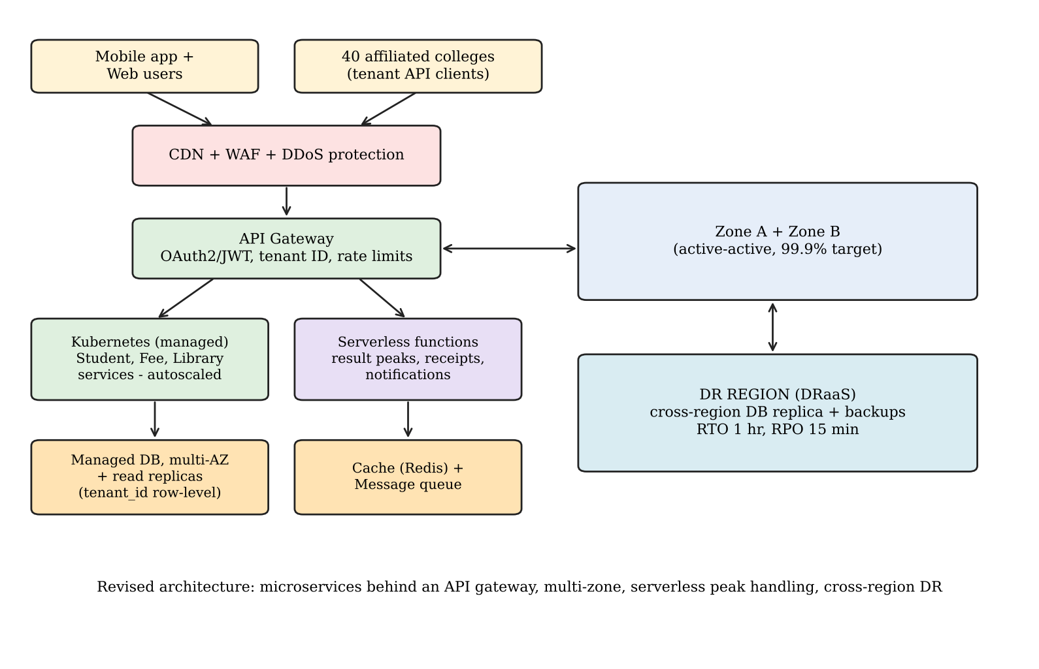
Figure 3: Revised architecture for mobile app and 40 affiliated colleges
Table 28: Changes in the revised design
Layer | Original | Revised
Entry and security | Load balancer and WAF | CDN, WAF and DDoS protection; API gateway with OAuth2/JWT, tenant identification and per-tenant rate limits
Compute | VMs and containers on PaaS | Managed Kubernetes (container orchestration) with horizontal auto-scaling for student, fee and library microservices; serverless functions for result peaks, receipts and notifications
Data | Single managed database | Multi-AZ managed database, read replicas, Redis cache and message queue; tenant_id row-level security
Availability | Single region, possibly single zone | Active-active across two zones and a cross-region DR replica (RTO 1 hour, RPO 15 minutes)
Service model mix | IaaS, PaaS, SaaS, DBaaS, DRaaS | More PaaS (container platform, API management), FaaS, BaaS for the mobile app; LMS and Email unchanged as SaaS
Virtualization approach | VMs plus containers on 4 to 6 hosts | Containers become the default for stateless services on a managed cluster; VMs only for stateful or legacy components

11.4 Evidence-Based Defence (2 Marks)
Capacity and availability calculations.
- Peak capacity needed: 10 × 4.2 = 42 SE; 42 ÷ 0.70 = 60 host-equivalents if served directly.
- Reduction measures: CDN and caching for static and repeated result requests, read replicas, queues for fee payments and serverless functions are assumed to remove about 40% of the load reaching the compute tier, giving about 36 host-equivalents at peak, needed only for the few weeks of admissions and exams.
- Because the extra capacity is provided by auto-scaling, the university pays for 36 host-equivalents only for peak hours, and about 3 times the baseline for the rest of the year.
- Availability: multi-zone design gives about 99.93% (about 6.1 hours per year); a DR region protects against regional failure. A load test (for example with JMeter or k6) at 10× the expected concurrent users is required to validate these estimates.
Cost comparison (₹ lakh per year; illustrative).
Table 29: Cost of original design under new load vs revised design
Item | Original design scaled to 10× load | Revised design
Compute and platform | 60 (always-on larger capacity) | 36 (containers with auto-scaling and serverless)
Database and storage | 10 | 14 (multi-AZ, replicas)
API gateway, CDN, WAF, cache | 3 | 10
DR and backup | 5 (basic) | 8 (DRaaS and cross-region)
Staff and monitoring | 13 | 10 (more automation)
Annual total | 91 | 78
3-year total (including migration) | 273 | 244 (78 × 3 + 10 redesign effort)

The revised design costs about ₹29 lakh less over three years than simply enlarging the original design, and unlike it, meets the 99.9% target. The cost can be further controlled through budgets and alerts, reserved capacity for baseline load and, optionally, a per-transaction or per-college service fee to the affiliated colleges. These numbers are planning estimates and should be updated with provider quotations.
Security and multi-tenancy. Each college receives its own API credentials and scopes (OAuth2 client credentials); the gateway adds the tenant identifier to each request; the database enforces row-level security by tenant_id (or separate schemas for high-sensitivity data); per-tenant rate limits and quotas prevent a noisy tenant from affecting others; data is encrypted in transit and at rest, with per-tenant keys if required; fee payment goes through a PCI-DSS compliant payment gateway so that card data never touches university servers; audit logs are kept per tenant.
Trade-offs.
- Vendor lock-in: managed Kubernetes, standard SQL and open APIs keep the design reasonably portable, but serverless and API gateway features are provider-specific; mitigate with abstraction layers and exportable data.
- Complexity: microservices, orchestration and multi-region add operational complexity; mitigate by using managed services, infrastructure as code, monitoring and staff training.
- Migration effort: moving from the original design to containers and API-based services needs extra development and testing (estimated ₹10 lakh and 2 to 3 months); this is accepted in return for availability and scale.
Final decision: the original solution should be modified, not redesigned. The service-model strategy is retained, and the API, compute, data and availability layers are strengthened with an API gateway, container orchestration, serverless components, multi-zone deployment and a cross-region DR site, which together meet the 10× load, 99.9% availability and budget constraints.

